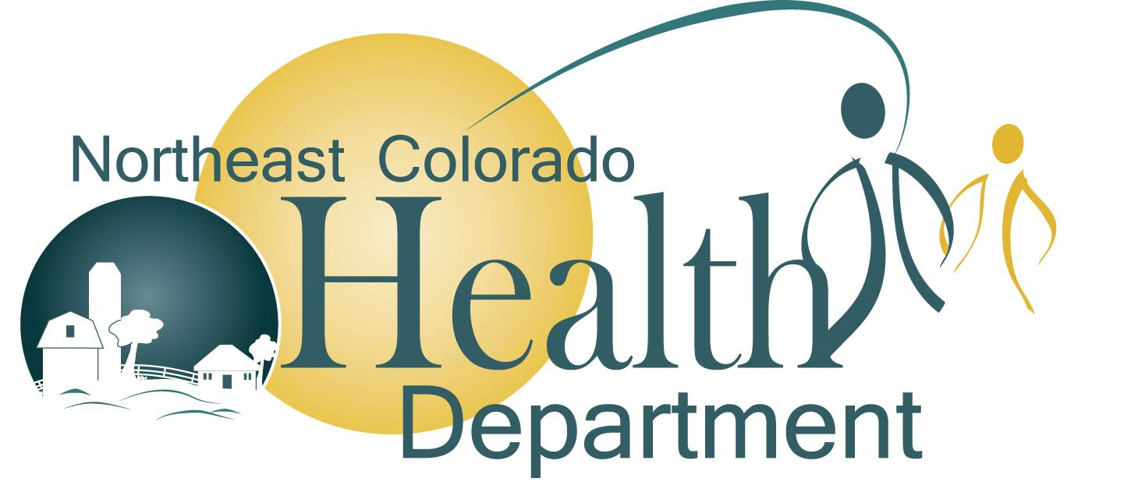
NEWS RELEASE

Kylee Harless
Public Health Communication Specialist
(970) 522-3741 x1246
kyleeh@nchd.org

October 14, 2020

FOR IMMEDIATE RELEASE

NCHD calls the counties to take action

Sterling, Colo. – October 14, 2020: COVID-19 is still causing increasing issues in some of our counties. COVID-19 has taken loved ones, changed many of our lives, and it’s not asking for our opinion. We at NCHD are calling upon everyone to do their part. We aren’t asking as your health department; we are asking you as your fellow community members to put your community spirit on display and lead by example.
COVID-19 is a virus that does not play favorites or follow political lines; it can affect anyone no matter who they are. Over the past two weeks, three of our six counties have been among just five in the entire state with a case positivity rate of over 5%, this is very concerning. The case positivity rate is the ratio of positive test results to the total number of tests conducted. It is critical that we try to keep this rate below a 5% threshold. Doing so helps ensure that long-term care facilities, hospitals, restaurants, and business can continue to keep the level of normalcy that we have enjoyed in the past few months.

This virus is affecting people differently but has proven to be very harmful and have long term effects for many of its victims. Additionally, it has changed the way we live, and by the inaction of far too many people, we are letting it dictate how our lives continue to play out. What we do know is that everyone is already aware of how to stop COVID-19 from spreading. As our friends and neighbors, we beg for your help and we are asking you to do your part to help turn things around. We can easily decrease our numbers if more people just find it in their hearts to do the right thing.
What we all need to understand is that we truly are in control of this virus, we just have to act like it. This virus needs to play by our rules and not the other way around. We need to take control and stop the spread of the virus locally before any more lives are lost, or before additional restrictions are forced upon us again.
To make things even more heartbreaking, we know that residents of our long-term care facilities are among those who are suffering the most. Not only are they suffering health-wise but suffering mentally. Many of the residents are experiencing depression, loneliness, loss of appetite and a general failure to thrive because of the loss in visitation.
This is not fair to them, and it is also not fair to all of us community members. We all need to do our part so that friends and family are able to continue to see their loved ones in a long-term care facility and in doing so allows for our loved ones to flourish.

As community members it really is in our nature to do our part, so please spread Kindness not COVID. Let's show the rest of the state that we do care about each other and some virus isn’t going to stop us from doing what our communities were made to do, and that is pick up our neighbors when our neighbors are down. In doing our part this will allow us to put COVID-19 in our rearview mirror, and we can get back to the lives we used to have and wish we could have again.

# # #

